**Installation Instructions**

**If already installed:**

**How to run the code:**

* Unzip the code ‘pair_text_analysis.zip’ in any preferred location on your computer.

(*For example:* /Users/bindu/Desktop)

* Change the ‘config/config.yml’ file as mentioned in the user guide.
* Open the Anaconda Prompt (recommended) or Command Prompt. Open Terminal if using Mac OS.
* Navigate to the folder containing the ‘runAnalysis.py’ file by typing ‘cd folder_path’

(*For example:* Type ‘cd /Users/bindu/Desktop/pair_text_analysis’)

* Run the python code by typing ‘python runAnalysis.py’.
* Wait until you see ‘Done!!’.

***Note:*** Check if the conda environment is activated by typing ‘python’ in the Command Prompt. If there is a warning such as ‘*This Python interpreter is in a conda environment, but the environment has not been activated. Libraries may fail to load’*, type ‘exit()’ and then type ‘conda activate base’. Then, proceed to running *‘python runAnalysis.py’*. In order to avoid these kinds of errors, use of Anaconda Prompt instead of Command Prompt is recommended.

**How to install:**

**Install Anaconda**

* Download the Anaconda installer: <https://www.anaconda.com/distribution/#windows>
* Installing Anaconda installs Python automatically. Make sure to check the box ‘Register Anaconda as my default Python 3.7’.
* Run the installer, make sure to check the box “Add Anaconda to my PATH environment variable”

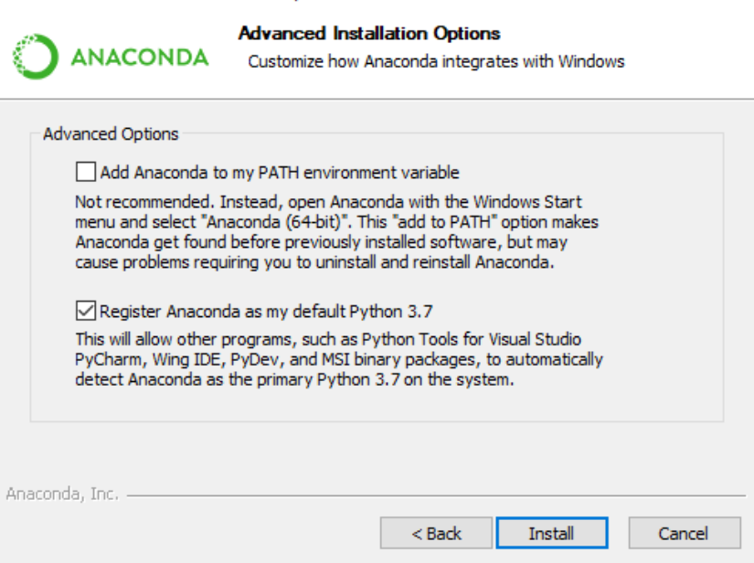

* More questions can be referred to <https://docs.anaconda.com/anaconda/install/>

**Install C Compiler (for Windows OS only)**

* Download MinGW: <https://sourceforge.net/projects/mingw-w64/>
* Run the installation Manager and follow the pop up windows.
* Select all options

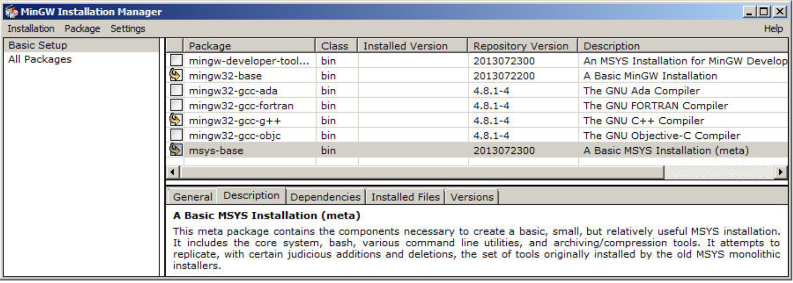

* Click ‘Installation’ on top left, then ‘Apply’
* Type ‘environment variables’ in windows search bar

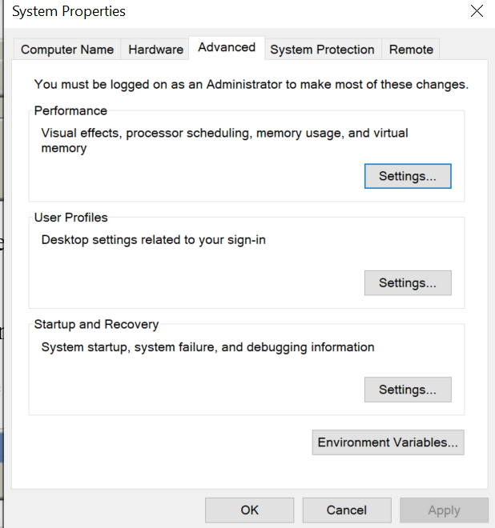

* Click ‘Environment Variables…’, find ‘PATH’, then click ‘Edit’, we will update in both user variables and system variables.

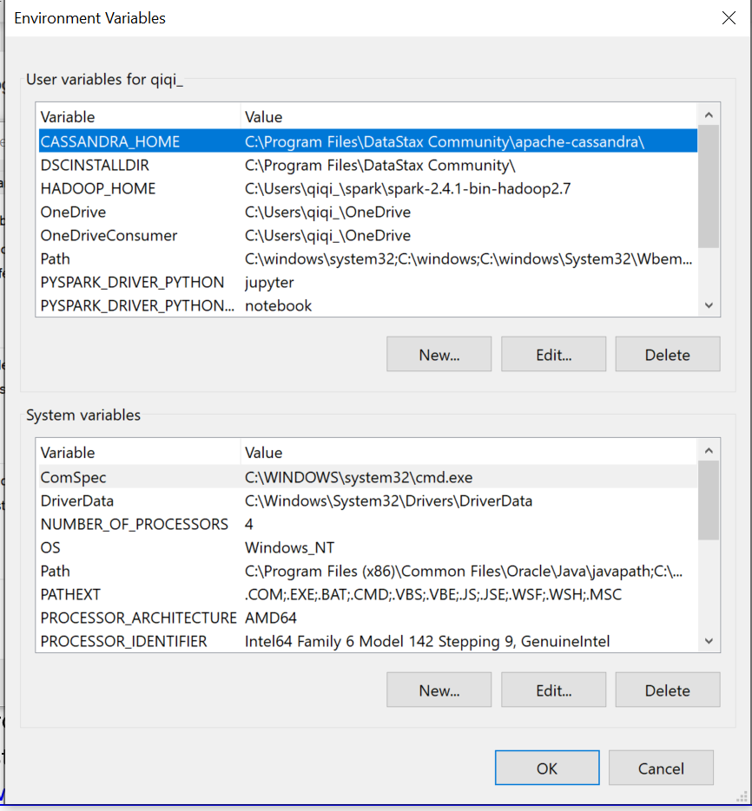

* Click ‘New’ on right hand side, copy **C:\MinGW\bin;C:\MinGW\msys\1.0\bin;** paste at the empty place, then click ‘OK’.

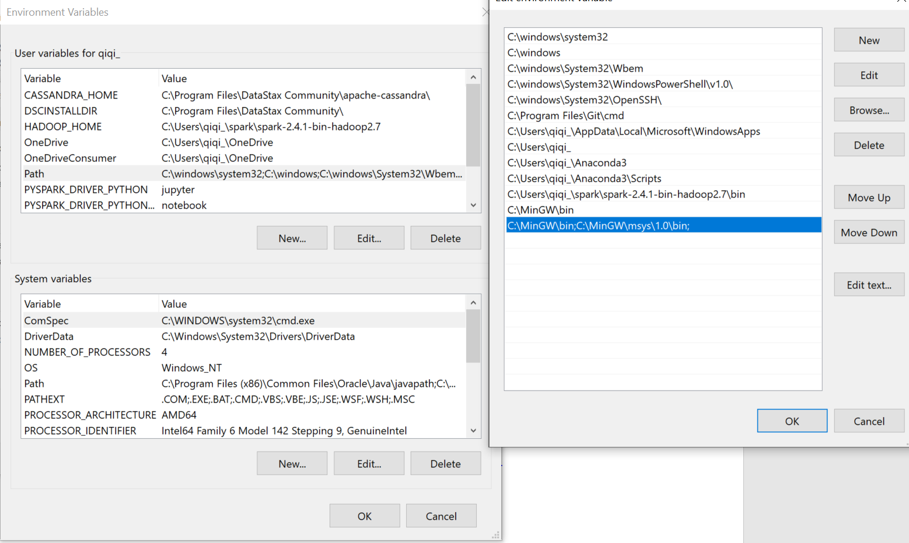

* Repeat the same in ‘System variables’
* More questions can be referred to <https://www.ics.uci.edu/~pattis/common/handouts/mingweclipse/mingw.html>

**Install Libraries**

* Type ‘cmd’ in windows search bar, open Command Prompt.
* Type ‘conda install gensim’

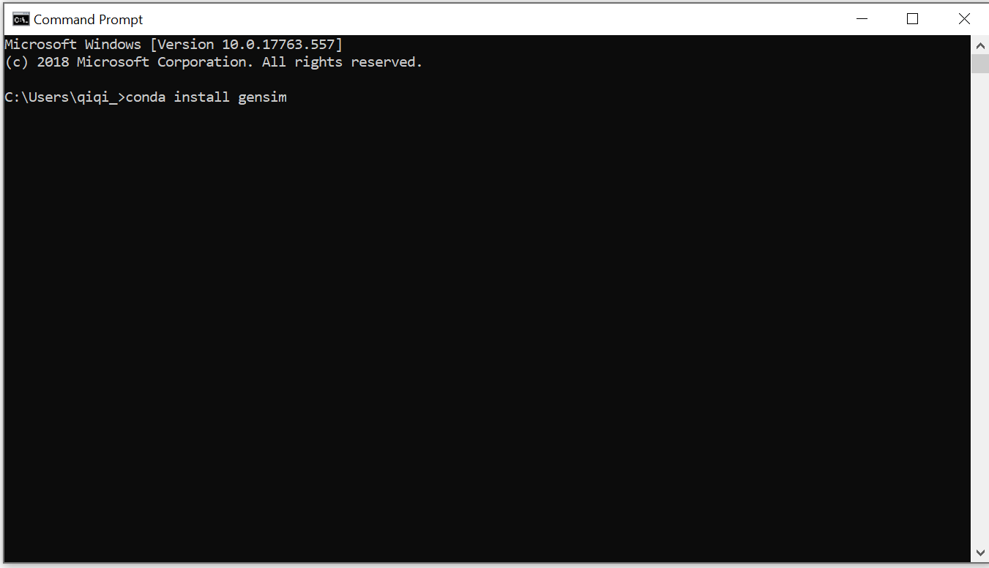

* After genism has installed, type ‘pip install nltk’
* After installed, type ‘python’
* Type ‘import gensim’
* Type ‘gensim.models.word2vec.FAST_VERSION’

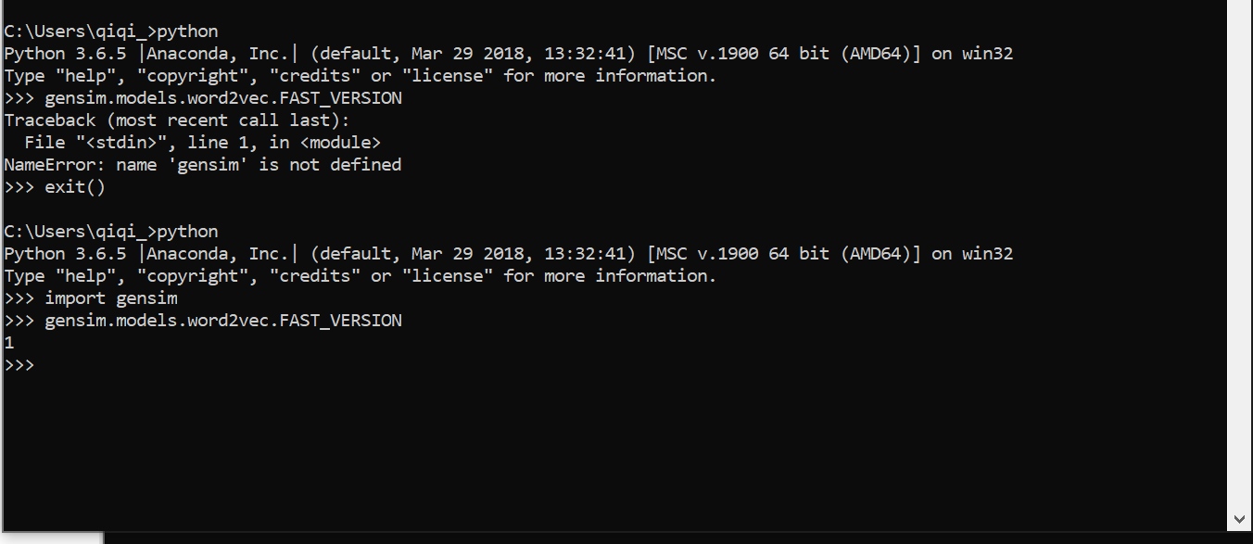

* Make sure it returns 1!
* Type ‘import nltk’
* Type ‘nltk.download(‘all’)’
* After finishing downloads, type ‘exit()’
* Continue to install other libraries, type the following commands one after the other:
* ‘pip install pandas’
* ‘pip install numpy’
* ‘pip install math’
* ‘pip install re’
* ‘pip install collections’
* ‘pip install spacy’
* ‘pip install vaderSentiment’
* ‘pip install pyspellchecker’
* ‘pip install matplotlib’
* ‘pip install fpdf’
* ‘pip install wordcloud’
* ‘pip install PyPDF2’
* ‘pip install logging’
* ‘pip install sys’
* ‘pip install os’
* ‘pip install shutil’
* ‘pip install warnings’
* ‘pip install errno’
* ‘python -m spacy download **en_core_web_sm’**
* Message like ‘Requirement already satisfied’ can be ignored
* Installation of any library can be verified by typing ‘python’ and then ‘import library_name’. If there is no error, it means the library is installed. Type ‘exit()’ to return back from python to Command Prompt.

